Permutable (Anagrammatic) Primes
# Source: AI Source: Provided by: [Data Path: Persons Table -> ID Column: 1, Name_En Column: Motasem Essam] -> From: [ChatGPT] on [7/13/2026]
A permutable prime (also called an anagrammatic prime or absolute prime) is a prime number that remains prime under every possible permutation (rearrangement) of its decimal digits.
For example,
$$113$$
has the digit permutations
$$113, 131, 311.$$
Since all three numbers are prime, 113 is a permutable (anagrammatic) prime.
Permutable primes are studied in number theory, digit patterns, and computational mathematics.

Definition
# Source: AI Source: Provided by: [Data Path: Persons Table -> ID Column: 1, Name_En Column: Motasem Essam] -> From: [ChatGPT] on [7/13/2026]
A permutable (anagrammatic) prime is a prime number such that every distinct permutation of its decimal digits is also a prime number.
If any permutation is composite, then the number is not a permutable prime.

Rules for Permutable (Anagrammatic) Primes

1. The Original Number Must Be Prime
# Source: AI Source: Provided by: [Data Path: Persons Table -> ID Column: 1, Name_En Column: Motasem Essam] -> From: [ChatGPT] on [7/13/2026]
The starting number must be prime.
Example
$$113$$
is prime.

2. Generate Every Distinct Permutation of the Digits
# Source: AI Source: Provided by: [Data Path: Persons Table -> ID Column: 1, Name_En Column: Motasem Essam] -> From: [ChatGPT] on [7/13/2026]
Rearrange the digits in every possible order.
Example
For
$$113,$$
the distinct permutations are
$$113, 131, 311.$$
(The repeated permutation 113 arising from swapping identical 1s is counted only once.)

3. Every Permutation Must Be Prime
# Source: AI Source: Provided by: [Data Path: Persons Table -> ID Column: 1, Name_En Column: Motasem Essam] -> From: [ChatGPT] on [7/13/2026]
Each distinct permutation must also be prime.
Example
$$113, 131, 311$$
are all prime.
Therefore,
113 is a permutable prime.

4. If Any Permutation Is Composite, the Number Is Not a Permutable Prime
# Source: AI Source: Provided by: [Data Path: Persons Table -> ID Column: 1, Name_En Column: Motasem Essam] -> From: [ChatGPT] on [7/13/2026]
Example
Consider
$$137.$$
Its permutations include
$$371.$$
Since
$$371=7×53,$$
137 is not a permutable prime.

5. Multi-Digit Permutable Primes Cannot Contain Certain Digits
# Source: AI Source: Provided by: [Data Path: Persons Table -> ID Column: 1, Name_En Column: Motasem Essam] -> From: [ChatGPT] on [7/13/2026]
Except for the one-digit primes
$$2$$
and
$$5,$$
a multi-digit permutable prime cannot contain
$$0, 2, 4, 5, 6, 8.$$
Otherwise, one permutation would end with an even digit or 5, making it composite.
Example
The number
$$127$$
contains the digit
$$2.$$
One permutation is
$$172,$$
which is even.
Therefore,
127 cannot be a permutable prime.

6. Multi-Digit Permutable Primes Cannot Have a Digit Sum Divisible by 3
# Source: AI Source: Provided by: [Data Path: Persons Table -> ID Column: 1, Name_En Column: Motasem Essam] -> From: [ChatGPT] on [7/13/2026]
All permutations have the same digit sum.
If the digit sum is divisible by
$$3,$$
then every permutation is divisible by
$$3,$$
except possibly the number
$$3$$
itself.
Example
For
$$1995,$$
the digit sum is
$$1+9+9+5=24,$$
which is divisible by
$$3.$$
Therefore,
every permutation is divisible by
$$3,$$
so it cannot be a permutable prime.

7. Permutable Primes Are Extremely Rare
# Source: AI Source: Provided by: [Data Path: Persons Table -> ID Column: 1, Name_En Column: Motasem Essam] -> From: [ChatGPT] on [7/13/2026]
Because every digit arrangement must be prime, permutable primes become increasingly rare as the number of digits grows.

8. It Is Unknown Whether Infinitely Many Permutable Primes Exist
# Source: AI Source: Provided by: [Data Path: Persons Table -> ID Column: 1, Name_En Column: Motasem Essam] -> From: [ChatGPT] on [7/13/2026]
Mathematicians do not know whether infinitely many permutable primes exist.
This remains an open problem.

First Permutable (Anagrammatic) Primes
# Source: AI Source: Provided by: [Data Path: Persons Table -> ID Column: 1, Name_En Column: Motasem Essam] -> From: [ChatGPT] on [7/13/2026]
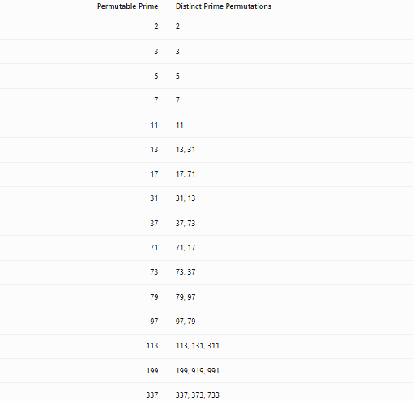
Permutable Prime | Distinct Prime Permutations
2 | 2
3 | 3
5 | 5
7 | 7
11 | 11
13 | 13, 31
17 | 17, 71
31 | 31, 13
37 | 37, 73
71 | 71, 17
73 | 73, 37
79 | 79, 97
97 | 97, 79
113 | 113, 131, 311
199 | 199, 919, 991
337 | 337, 373, 733

Examples
# Source: AI Source: Provided by: [Data Path: Persons Table -> ID Column: 1, Name_En Column: Motasem Essam] -> From: [ChatGPT] on [7/13/2026]
Example 1
Determine whether
$$13$$
is a permutable prime.
Permutations:
$$13, 31.$$
Both are prime.
Therefore,
13 is a permutable prime.

Example 2
Determine whether
$$113$$
is a permutable prime.
Permutations:
$$113, 131, 311.$$
All are prime.
Therefore,
113 is a permutable prime.

Example 3
Determine whether
$$199$$
is a permutable prime.
Permutations:
$$199, 919, 991.$$
All are prime.
Therefore,
199 is a permutable prime.

Example 4
Determine whether
$$137$$
is a permutable prime.
Permutations include
$$371.$$
Since
$$371=7×53,$$
137 is not a permutable prime.

Example 5
Determine whether
$$337$$
is a permutable prime.
Permutations:
$$337, 373, 733.$$
All are prime.
Therefore,
337 is a permutable prime.

Example 6
Determine whether
$$239$$
is a permutable prime.
One permutation is
$$923.$$
Since
$$923=13×71,$$
239 is not a permutable prime.

Common Permutable (Anagrammatic) Primes
# Source: AI Source: Provided by: [Data Path: Persons Table -> ID Column: 1, Name_En Column: Motasem Essam] -> From: [ChatGPT] on [7/13/2026]
Some well-known permutable primes are
$$2, \\ 3, \\ 5, \\ 7, \\ 11, \\ 13, \\ 17, \\ 31, \\ 37, \\ 71, \\ 73, \\ 79, \\ 97, \\ 113, \\ 199, \\ 337.$$

How to Determine Whether a Number Is a Permutable Prime
# Source: AI Source: Provided by: [Data Path: Persons Table -> ID Column: 1, Name_En Column: Motasem Essam] -> From: [ChatGPT] on [7/13/2026]
- Verify that the original number is prime.
- Generate every distinct permutation of its digits.
- Test each permutation for primality.
- If every permutation is prime, the number is a permutable prime.
Example
Check
$$199.$$
Permutations:
$$199, 919, 991.$$
All are prime.
Therefore,
199 is a permutable prime.

Real-Life Applications
# Source: AI Source: Provided by: [Data Path: Persons Table -> ID Column: 1, Name_En Column: Motasem Essam] -> From: [ChatGPT] on [7/13/2026]
Permutable primes are primarily used in:
- Number theory research
- Computational mathematics
- Prime number searches
- Primality testing
- Algorithm development
- Mathematical software
- Computer science
- Mathematics education
- Recreational mathematics
- Research in digit-based prime patterns

Real-Life Examples
# Source: AI Source: Provided by: [Data Path: Persons Table -> ID Column: 1, Name_En Column: Motasem Essam] -> From: [ChatGPT] on [7/13/2026]
1. Number Theory Research
Researchers study permutable primes to understand how digit rearrangements affect primality.

2. Computational Mathematics
Algorithms generate every permutation of a number's digits and test each for primality.

3. Prime Number Searches
Large prime databases are searched to identify anagrammatic prime families.

4. Mathematical Software
Computer algebra systems efficiently generate digit permutations and perform primality tests.

5. Recreational Mathematics
Permutable primes are a classic example of the interaction between combinatorics and prime numbers.

6. Mathematics Education
They illustrate how permutations, digit properties, and prime testing work together.

Common Mistakes
# Source: AI Source: Provided by: [Data Path: Persons Table -> ID Column: 1, Name_En Column: Motasem Essam] -> From: [ChatGPT] on [7/13/2026]
- Confusing permutable primes with circular primes. Circular primes require only cyclic rotations, while permutable primes require all possible digit rearrangements.
- Forgetting to test every distinct permutation.
- Ignoring repeated digits when counting distinct permutations.
- Assuming that if one permutation is prime, then all are.
- Forgetting that multi-digit permutable primes cannot contain the digits
$$0, 2, 4, 5, 6, 8.$$

Key Points
# Source: AI Source: Provided by: [Data Path: Persons Table -> ID Column: 1, Name_En Column: Motasem Essam] -> From: [ChatGPT] on [7/13/2026]
- A permutable (anagrammatic) prime remains prime under every distinct permutation of its digits.
- The original number and every permutation must be prime.
- Multi-digit permutable primes can contain only the digits
$$1, 3, 7, 9.$$
- Their digit sum cannot be divisible by
$$3.$$
- Permutable primes are much rarer than circular primes.
- Whether infinitely many permutable primes exist remains an open problem.

Permutable Primes vs. Circular Primes
# Source: AI Source: Provided by: [Data Path: Persons Table -> ID Column: 1, Name_En Column: Motasem Essam] -> From: [ChatGPT] on [7/13/2026]
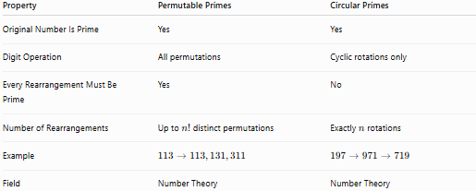
Property | Permutable Primes | Circular Primes
Original Number Is Prime | Yes | Yes
Digit Operation | All permutations | Cyclic rotations only
Every Rearrangement Must Be Prime | Yes | No
Number of Rearrangements | Up to $n!$distinct permutations | Exactly $n$rotations
Example | $$113→113,131,311$$ | $$197→971→719$$
Field | Number Theory | Number Theory

Conclusion
# Source: AI Source: Provided by: [Data Path: Persons Table -> ID Column: 1, Name_En Column: Motasem Essam] -> From: [ChatGPT] on [7/13/2026]
A permutable prime, also called an anagrammatic prime or absolute prime, is a prime number whose every distinct permutation of its decimal digits is also prime. This is one of the strongest digit-based prime properties, since all possible rearrangements must remain prime, not just reversals or rotations. Because of this strict requirement, permutable primes are extremely rare and are an important topic in number theory, computational mathematics, and recreational mathematics. Whether infinitely many permutable primes exist remains an open problem.

